Dependencies:
1.Download Git
2.Git Bash is mandatory for commandline usage
Structure:
My Special Tea
Tea Preparation
Water
Tea
Sugar
Water
Tea
Sugar
Recipe
Ingredient Cost
Ingredient

Steps:
1.Create a separate folder for git project
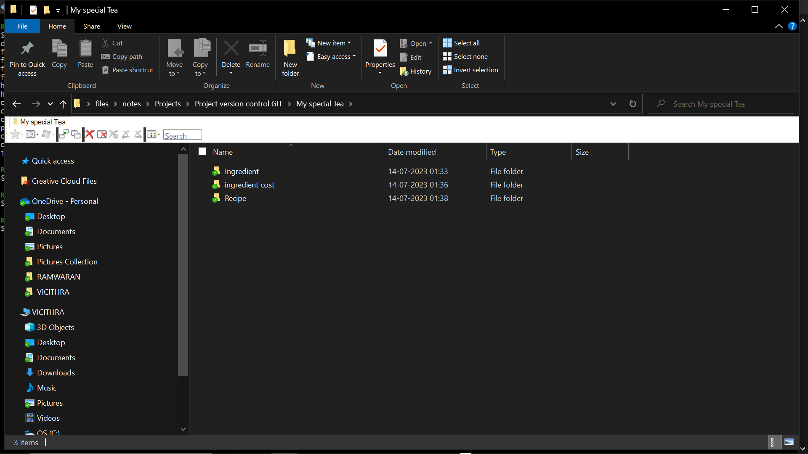
2.In git Bash, create the global username and email and default main branch
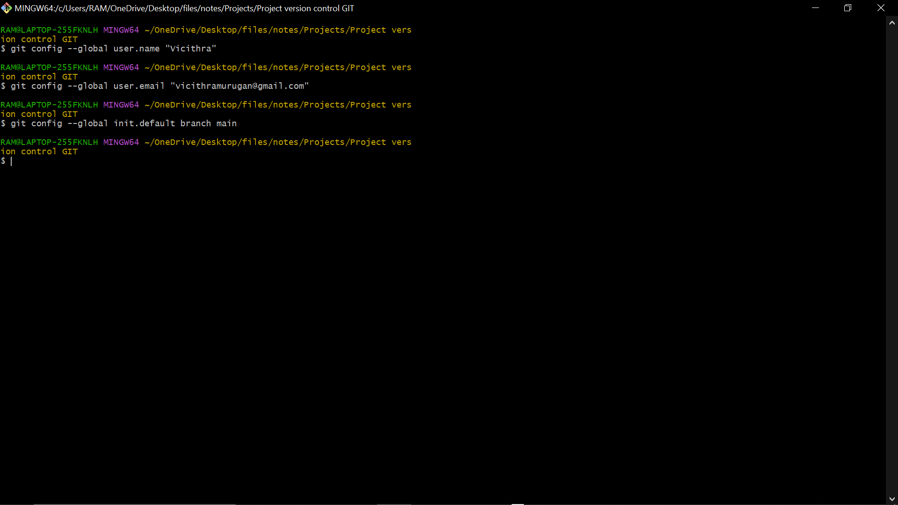
3.Initialise the git repository by code
git init
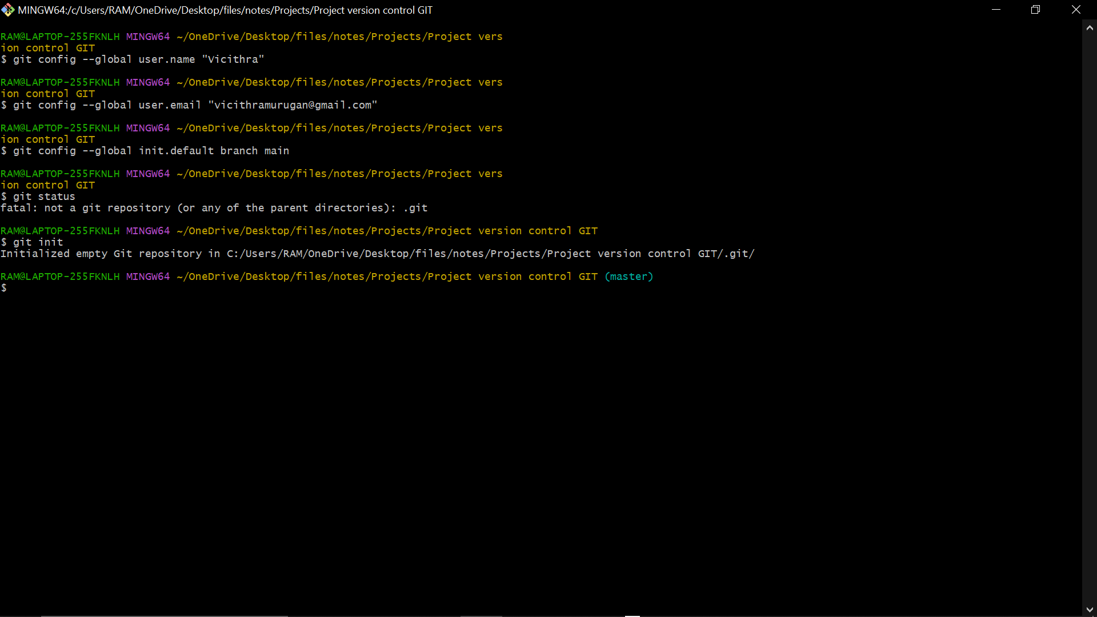
4.Modify to main branch:
$ git branch -m master main
5.Now add file to git
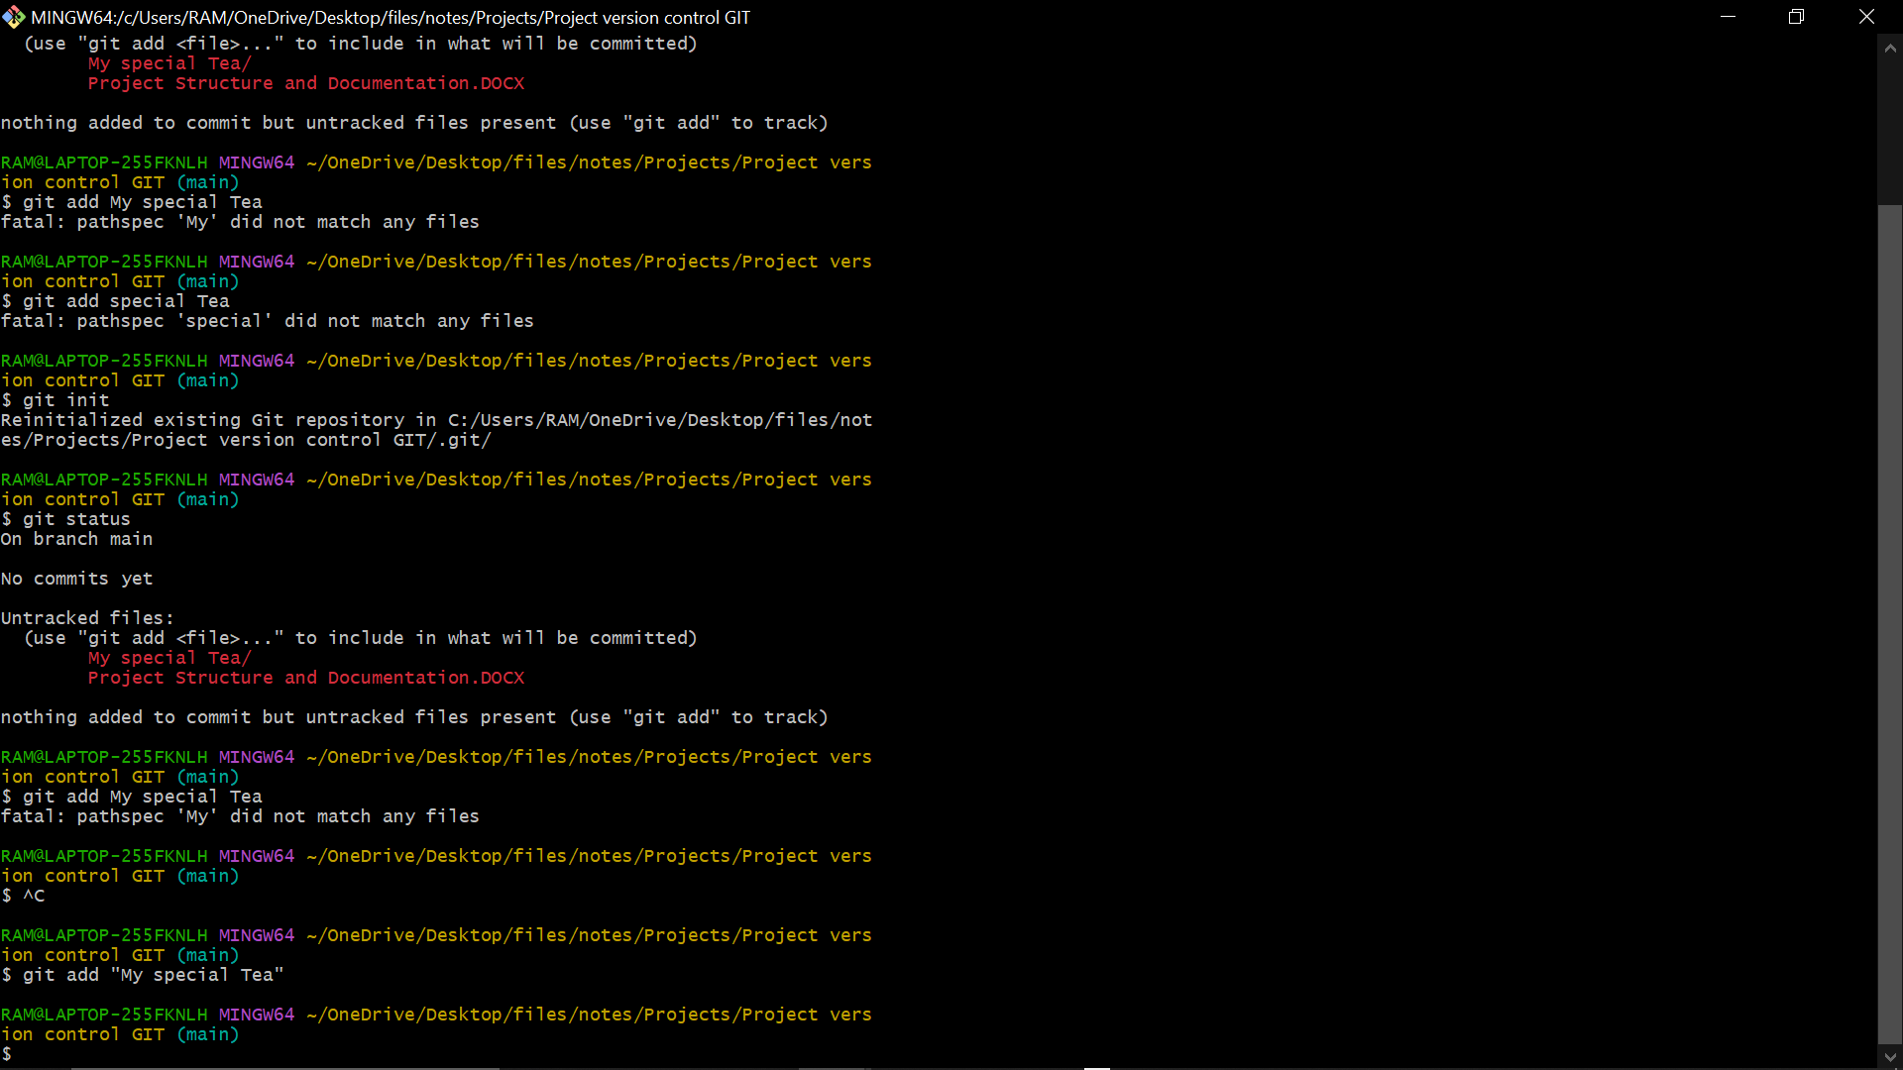
Enter the code: $ git commit -m "First Commit"
It is in creation mode
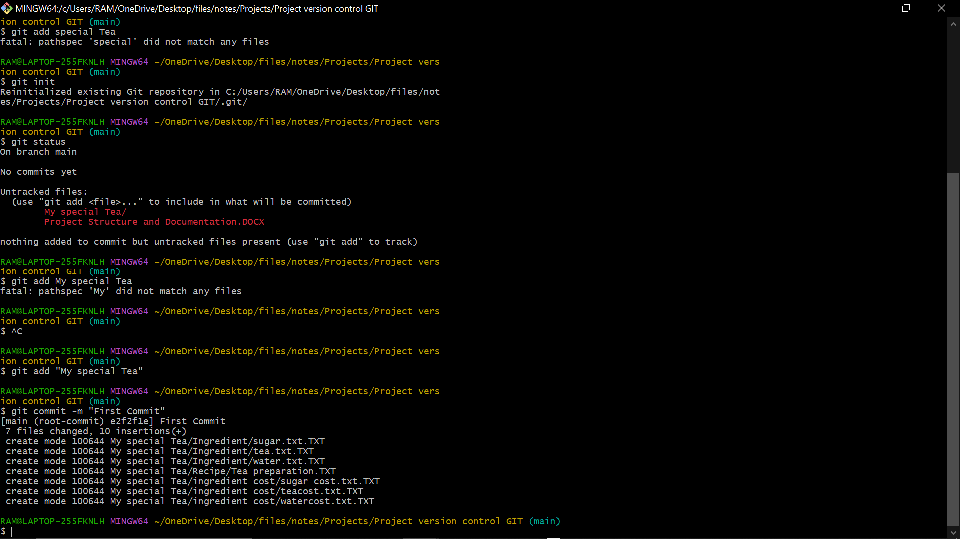
Use git log for getting details of first commit
Git Branching
1.Git branch – list the branches
2.Git branch tester – adds a new branch named tester
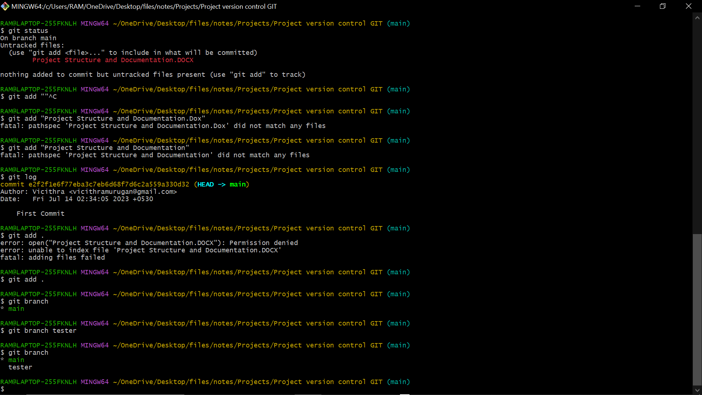
3.Switching to tester branch:
git switch tester
